India Vs China: A comparison of economic growth
Here is a comparison between Indian and Chinese economy
﻿
By Zee Media Bureau | Last Updated: Tuesday, September 5, 2017 - 14:02

0
Comment
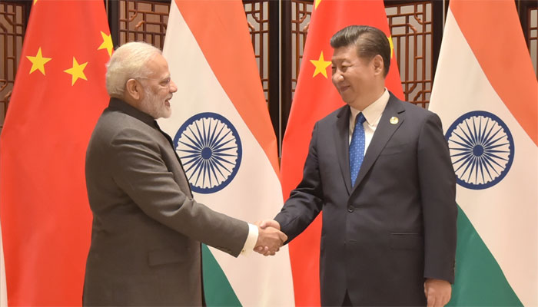
New Delhi: Prime Minister Narendra Modi and Chinese President Xi Jinping on Tuesday held their first substantial bilateral meeting on the sidelines of a summit of the BRICS grouping of nations after the Dokhlam standoff which had put ties between the two countries under strain.
Chinese President told PM Modi that the two Asian giants are development opportunities for each other, not threats.

Here is a comparison between Indian and Chinese economy
Economy Size
Chinese economy: USD 11.22 trillion.
Indian economy: USD 2.45 trillion.
GDP Growth Rate
India’s GDP growth for June (2017) quarter was at 5.7 percent.
China's GDP growth for second quarter (2017) was at 6.9 percent.
Trade
China's July (2017) trade balance was $46.74 billion.
India's July (2017) trade deficit was $11.49 billion.
India-China Bilateral Trade
India's trade deficit with China was at USD 46.56 billion (2016).
China's exports to India totaled USD 58.33 billion (2016).
India's exports to China was at USD 11.76 billion (2016).
Gold Reserves
China's gold reserves rose to $75.084 billion (Latest data).
India's gold reserves rose $19.94 billion (Latest data).
Forex Reserves
India's forex reserves was $3.081 trillion (Latest data).
China's forex reserves for July USD 394.55 billion (Latest data).
Unemployment Rate
The registered unemployment rate in Chinese cities stood at 3.95 percent at the end of the second quarter (2017), the lowest level in recent years.
India's number of employed in August (2017) was at 4.4%

India vs. China
Home > Factbook > Country Comparisons

Geography
 | India | China
Location | Southern Asia, bordering the Arabian Sea and the Bay of Bengal, between Burma and Pakistan | Eastern Asia, bordering the East China Sea, Korea Bay, Yellow Sea, and South China Sea, between North Korea and Vietnam
Geographic coordinates | 20 00 N, 77 00 E | 35 00 N, 105 00 E
Map references | Asia | Asia
Area | total: 3,287,263 sq km  land: 2,973,193 sq km  water: 314,070 sq km | total: 9,596,960 sq km  land: 9,326,410 sq km  water: 270,550 sq km
Area - comparative | slightly more than one-third the size of the US | slightly smaller than the US
Land boundaries | total: 13,888 km  border countries (6): Bangladesh 4,142 km, Bhutan 659 km, Burma 1,468 km, China 2,659 km, Nepal 1,770 km, Pakistan 3,190 km | total: 22,457 km  border countries (14): Afghanistan 91 km, Bhutan 477 km, Burma 2,129 km, India 2,659 km, Kazakhstan 1,765 km, North Korea 1,352 km, Kyrgyzstan 1,063 km, Laos 475 km, Mongolia 4,630 km, Nepal 1,389 km, Pakistan 438 km, Russia (northeast) 4,133 km, Russia (northwest) 46 km, Tajikistan 477 km, Vietnam 1,297 km  regional border(s) (2): Hong Kong 33 km, Macau 3 km
Coastline | 7,000 km | 14,500 km
Maritime claims | territorial sea: 12 nm  contiguous zone: 24 nm  exclusive economic zone: 200 nm  continental shelf: 200 nm or to the edge of the continental margin | territorial sea: 12 nm  contiguous zone: 24 nm  exclusive economic zone: 200 nm  continental shelf: 200 nm or to the edge of the continental margin
Climate | varies from tropical monsoon in south to temperate in north | extremely diverse; tropical in south to subarctic in north
Terrain | upland plain (Deccan Plateau) in south, flat to rolling plain along the Ganges, deserts in west, Himalayas in north | mostly mountains, high plateaus, deserts in west; plains, deltas, and hills in east
Elevation extremes | mean elevation: 160 m  elevation extremes: lowest point: Indian Ocean 0 m  highest point: Kanchenjunga 8,598 m | mean elevation: 1,840 m  elevation extremes: lowest point: Turpan Pendi -154 m  highest point: Mount Everest 8,850 m (highest peak in Asia and highest point on earth above sea level)
Natural resources | coal (fourth-largest reserves in the world), iron ore, manganese, mica, bauxite, rare earth elements, titanium ore, chromite, natural gas, diamonds, petroleum, limestone, arable land | coal, iron ore, petroleum, natural gas, mercury, tin, tungsten, antimony, manganese, molybdenum, vanadium, magnetite, aluminum, lead, zinc, rare earth elements, uranium, hydropower potential (world's largest), arable land
Land use | agricultural land: 60.5%  arable land 52.8%; permanent crops 4.2%; permanent pasture 3.5%  forest: 23.1%  other: 16.4% (2011 est.) | agricultural land: 54.7%  arable land 11.3%; permanent crops 1.6%; permanent pasture 41.8%  forest: 22.3%  other: 23% (2011 est.)
Irrigated land | 667,000 sq km (2012) | 690,070 sq km (2012)
Natural hazards | droughts; flash floods, as well as widespread and destructive flooding from monsoonal rains; severe thunderstorms; earthquakes  volcanism: Barren Island (elev. 354 m) in the Andaman Sea has been active in recent years | frequent typhoons (about five per year along southern and eastern coasts); damaging floods; tsunamis; earthquakes; droughts; land subsidence  volcanism: China contains some historically active volcanoes including Changbaishan (also known as Baitoushan, Baegdu, or P'aektu-san), Hainan Dao, and Kunlun although most have been relatively inactive in recent centuries
Environment - current issues | deforestation; soil erosion; overgrazing; desertification; air pollution from industrial effluents and vehicle emissions; water pollution from raw sewage and runoff of agricultural pesticides; tap water is not potable throughout the country; huge and growing population is overstraining natural resources | air pollution (greenhouse gases, sulfur dioxide particulates) from reliance on coal produces acid rain; China is the world's largest single emitter of carbon dioxide from the burning of fossil fuels; water shortages, particularly in the north; water pollution from untreated wastes; deforestation; estimated loss of one-fifth of agricultural land since 1949 to soil erosion and economic development; desertification; trade in endangered species
Environment - international agreements | party to: Antarctic-Environmental Protocol, Antarctic-Marine Living Resources, Antarctic Treaty, Biodiversity, Climate Change, Climate Change-Kyoto Protocol, Desertification, Endangered Species, Environmental Modification, Hazardous Wastes, Law of the Sea, Ozone Layer Protection, Ship Pollution, Tropical Timber 83, Tropical Timber 94, Wetlands, Whaling  signed, but not ratified: none of the selected agreements | party to: Antarctic-Environmental Protocol, Antarctic Treaty, Biodiversity, Climate Change, Climate Change-Kyoto Protocol, Desertification, Endangered Species, Environmental Modification, Hazardous Wastes, Law of the Sea, Marine Dumping, Ozone Layer Protection, Ship Pollution, Tropical Timber 83, Tropical Timber 94, Wetlands, Whaling  signed, but not ratified: none of the selected agreements
Geography - note | dominates South Asian subcontinent; near important Indian Ocean trade routes; Kanchenjunga, third tallest mountain in the world, lies on the border with Nepal | world's fourth largest country (after Russia, Canada, and US) and largest country situated entirely in Asia; Mount Everest on the border with Nepal is the world's tallest peak above sea level
Population distribution | with the notable exception of the deserts in the northwest, including the Thar Desert, and the mountain fringe in the north, a very high population density exists throughout most of the country; the core of the population is in the north along the banks of the Ganges, with other river valleys and southern coastal areas also having large population concentrations | overwhelming majority of the population is found in the eastern half of the country; the west, with its vast mountainous and desert areas, remains sparsely populated; though ranked first in the world in total population, overall density is less than that of many other countries in Asia and Europe; high population density is found along the Yangtze and Yellow River valleys, the Xi Jiang River delta, the Sichuan Basin (around Chengdu), in and around Beijing, and the industrial area around Shenyang

